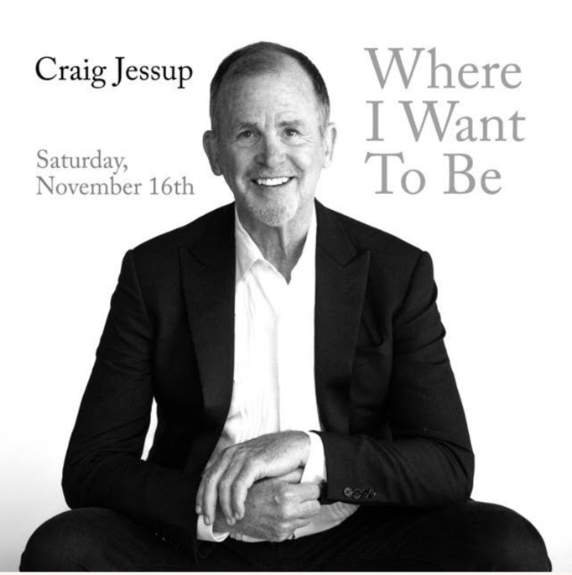
FOR IMMEDIATE RELEASE
Press contact: 415-637-7786

CRAIG JESSUP
WHERE I WANT TO BE
with Noah Bossert, musical director
Daniel Fabricant, bass; Nathaniel Welch, drums

Saturday, November 16, 2024
Throckmorton Theatre, 142 Throckmorton Ave., Mill Valley
8:00 p.m.

Tickets: $55 reserved; $45 general
https://www.throckmortontheatre.org/events/craig-jessups-where-i-want-to-be
415-383-9600

A veteran of cabaret and musical theater stages around the world, Craig Jessup is thrilled to bring his latest cabaret show, Where I Want to Be to the Throckmorton Theatre on Nov. 16 for one performance only. The song list will include gems from the Great American Songbook by the likes of the Gershwins and Rodgers and Hart as well as a taste of Broadway’s best from Stephen Sondheim, Cy Coleman and Stephen Schwartz. There will also be some Jessup originals and perhaps some surprises from Billy Joel and the masterminds behind ABBA.

Jessup will be accompanied by Musical Director Noah Bossert with bassist Daniel Fabricant and drummer Nathaniel Welch.

Craig Jessup was described by the San Francisco Chronicle as a performer who can be “playful or twangy, or edgy and electric. His singing also has a narrative quality that betrays his musical theater background. Each lyric springs from a deep and distinct emotion; each bit of phrasing is carefully sculpted to communicate an idea with clarity and dynamism.”

If Jessup’s name sounds familiar, that’s probably because he has played theaters, cabarets and concert halls throughout the U.S., Canada and Europe for more than two decades. Jessup teamed with Ruth Hastings and Barry Lloyd in 1977 to form Ruth Hastings & Co., and the trio played nearly every nightclub in San Francisco Golden Age of Cabaret including Le Domino, Chez Jacques, Gordon’s, Fanny’s, Trinity Place and the Plush Room, culminating in a sold-out concert at the Geary Theatre which was recorded live. A highly successful run of Jacques Brel is Alive and Well and Living in Paris at Chez Jacques resulted in an invitation to perform the acclaimed musical revue in Brussels, Belgium at the Belgian National Opera Company just after Brel’s death.

On his own, Jessup, who was described by the San Francisco Examiner as “smooth, clever and quite wonderful,” has appeared in musicals and revues with Marin’s Alter Theater Ensemble, Rohnert Park’s Paciﬁc Alliance Theatre Company, Broadway by the Bay (San Mateo), California Conservatory Theatre, 42nd Street Moon, the Aurora Theatre Company and Artstreet Theatre.

FOR MORE INFORMATION
Watch videos and hear music samples at www.craigjessup.com.
Download photos at https://www.craigjessup.com/press
FOR CALENDAR EDITORS
Craig Jessup: Where I Want to Be
Saturday, November 16, 2024
8 p.m.
Throckmorton Theatre, 142 Throckmorton Ave., Mill Valley
Tickets $45-$55
https://www.throckmortontheatre.org/events/craig-jessups-where-i-want-to-be
415-383-9600

